**Answer1**: Class name is “DemoBlaze”

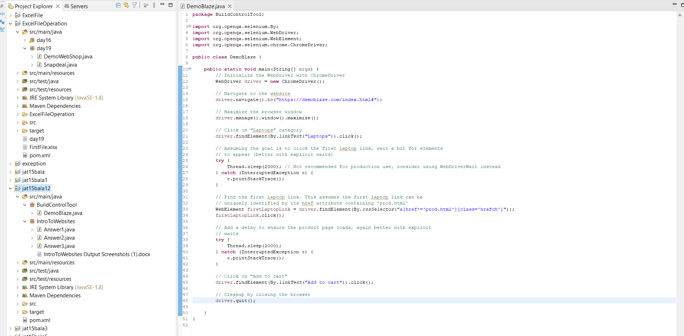

Browser Screenshot

